**CIS 353 Notes**

Week 3

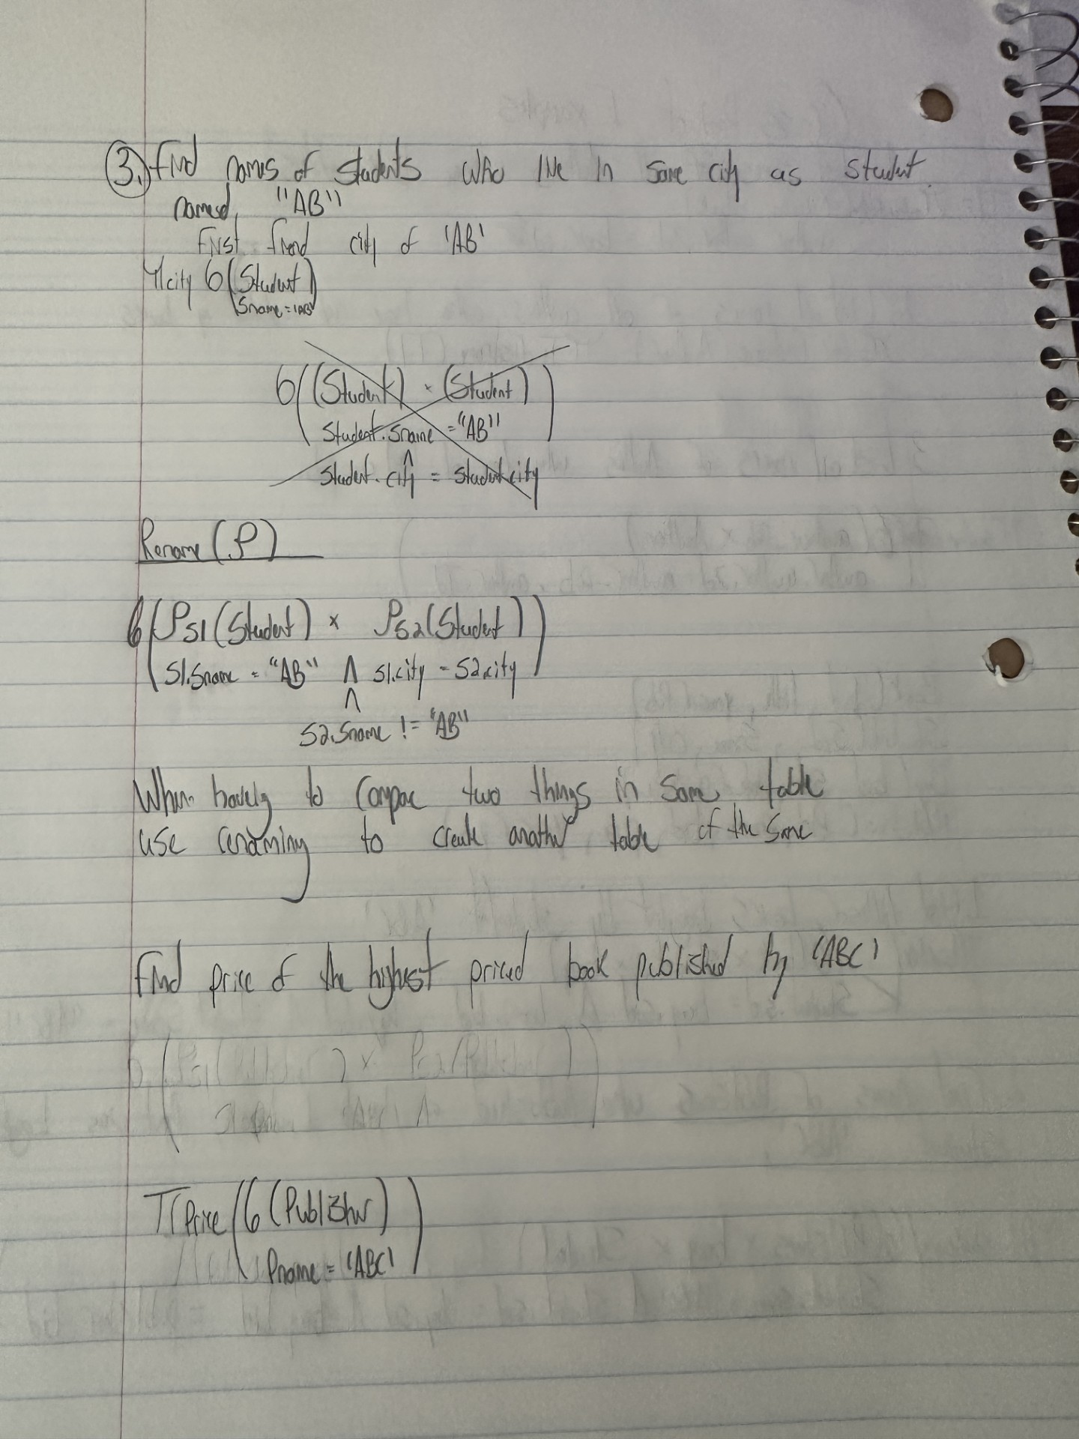

Join  
• Joins are compound operators (like intersection):  
– Generally, 𝜎<conditions>( R × S)  
• Two kinds:  
• Inner Join:  
– Theta Join ( ⋈𝛳 ): join on logical expression #  
– Equi-Join: theta join with theta being a conjunction of equalities  
– Natural Join ( ⋈ ): equi-join on all matching column names  
• Outer Join:  
- Left Outer Join  
- Right Outer Join  
- Full Outer Join

THETA

Compares tuples when doing the join based on if a certain data points in one is greater than the other.

R1(comparison point)>R2(comparison point)

EQUI

Compares tuples when doing the join based on if a certain data points in each are equal.

R1(comparison point)=R2(comparison point)

NATURAL

Special case of Equi-join in which equalities are specified for all

Left outer join

* Whatever that is in the left table will be in the join table
* If data matches in common column in the second table then we will take the extra data in the second table Else leave it behind

Right Outer Join

* Whatever that is in the right table will be in the join table
* If data matches in common column in the second table then we will take the extra data in the second table Else leave it behind

Full Outer Join

Examples:

Must identify sailors who’ve reserved red  
boats, sailors who’ve reserved green boats, then find the intersection  
(note that sid is a key for Sailors):  
ρ(Tempred, 𝜋sid((σcolor=’red’Boats) ⨝ Reserves))  
ρ(Tempgreen, 𝜋sid((σcolor=’green’Boats ⨝ Reserves))  
𝜋sname((Tempred ∩ Tempgreen) ⨝ Sailors)